Coffee Machine

1. What does the product do?

It's the Coffee Machine, one of the appliances I have the most attachment. Also our, Old Keurig Coffee Machine too. It a traditional drip coffee machine used to brew coffee.

1. Who will use it? Where? When? Why?

The product mostly used in households, and the target audience for the product is households, which love to brew their 'ground coffee' over having 'instant coffee'. Consuming 'Ground Coffee' over 'Instant Coffee' is always a healthier option to opt for.

Our modular product can also make 'Tea,' so somehow, it addresses multiple demands, catering to a broader array of consumers.

1. What are their aspirations? How do they see themselves?

As a product, the developers see themselves to modularize the design further so that a given design could incorporate more modularity. Down the line in the future, they could develop a more modularized and robust design. A modular design in the direction is that it could facilitate a coffee pod and ground coffee in the same machine. Currently, If you want a pod-based coffee, you need a different device and different coffee filters. That's the reason we have two different coffee machine's in the house. A design that 'one fix for all' should be one among their future aspirations.

1. What aesthetics were used? Why?

The use of Aesthetics in developing a coffee machine is very integral because it happens to one of the things that increase the cosmopolitan appeal of a kitchen and its modern setting.

In this case, transparent Jar, glossy finish, and compact yet trendy design elements have been duly inculcated in the design. If you see over the years, the design has been braced-up on the lines of aesthetics exponentially to the point that the late 70's Ugly looking Coffee Makers (My Grandpa had one) now look quite aesthetically pleasing, and they tend to contribute towards the overall aesthetics of the modular kitchens.

1. What are the associations with the product? How did the designer create them? Why?

Product Associations are the household coffee makers, which could be used at home and produce a decent number of coffee cups with minimum energy requirements.

The drip coffee was one of the key developments on the lines that the consumer has minimum intervention in making the coffee, and the process should be designed so that it's 'hassle-free'. Now, the intervention has been limited to the point that the consumer has to provide the ingredients/raw materials to make a coffee cup. This design can be categorized as the essential products which have introduced semi-automation in our everyday tasks itself.

1. What perceptions? What is your reaction to the product? What made you feel that way?

Being an AeroPress coffee fan-boy, I wasn't expecting much from the product, though. On the contrary, the product yielded some decent coffee, but some performance has been compromised in the due process of automation.

The design needs a little tweak. As of now, when your coffee is brewed, the machine automatically switches on the thermal plate beneath the Jar. This heating leads to cooking the coffee that contradicts the entire process of coffee-making. The coffee needs to keep warm but not cooked.

1. How (intentionally or unintentionally) did the designer create that perception?

The perception developed over time with the due usage of the product, and I would categorize that under the unintentional perception. But indeed, the perception that the machine would yield 'Great Coffee' was never articulated or put forward in the first place because the device utilizes the 'drip process' to brew the coffee. I agree the machine is a 'perfect fit' for working professionals, who need their cup of coffee to kickstart their day, but Yes, A Coffee enthusiast like me would never be a fan of the 'drip process'.

1. And finally, what was the designer trying to say with the product?

The designer effectively conveyed that this Coffee Machine is a quick-fix to reduce the effort involved in making coffee, which could be effectively utilized in a compact kitchen setting. Simultaneously, the machine is energy-efficient, making it an ideal home appliance to be bought for the home.

Question 2:

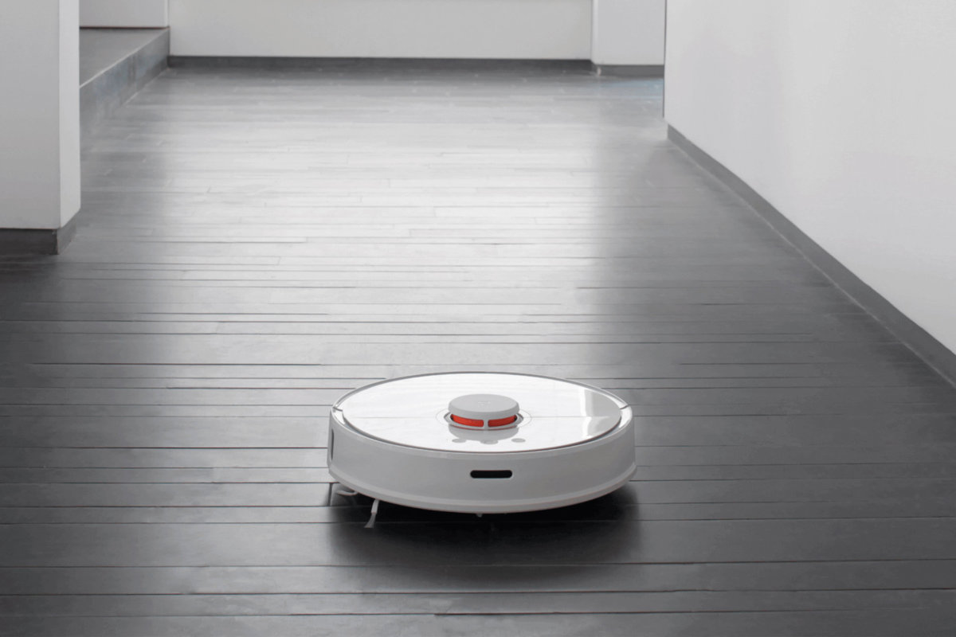

Robo Cleaner (Kobuki Platform)

This is one of the products we regularly see in our lab, i.e., 'Robo-Cleaner'(It's used to understand developing products on the same platform in our lab). I find the design very ugly and very bland.

I always wanted to increase the product's lateral height and instill the figure of minions or Spongebob into the design. Being a fan of Minions, I always wanted to recreate how cool it will be if a minion is cleaning your home. (Somewhat similar on the lines of 'Despicable Me 2' Movie).



Somewhere on these lines as in the above picture. Now, the point is if you have kids(Older kids like me) in the house and you want automatic vacuum cleaner in the house, this product is apt and perfect, even to create a good vibe in the house and even good enough to entertain kids in the house.